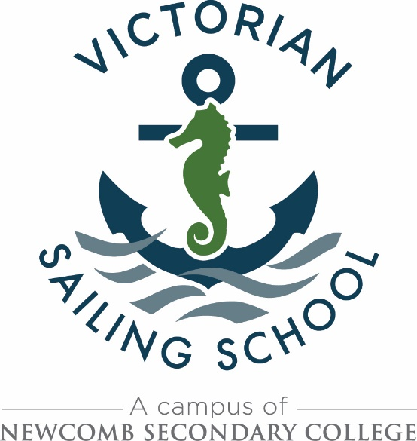

The Victorian Sailing School is the Eastern Beach Campus of Newcomb Secondary College and is a state-wide resource for DET Secondary Schools / Colleges. During 2020 programs will welcome groups from as far as Bright, Shepparton, Korumburra and all Melbourne metropolitan regions.

The Victorian Sailing School is now calling for expressions of interest from DET Secondary Schools / Colleges wishing to enrol in sailing programs for the 2021 school year.

Sailing lends itself to be an integral part of the following programs:

- VCE Outdoor and Environmental Studies
- Integrated learning for Middle Years – Outdoor Education and/or Physical Education electives
- Student Leadership
- Advance and the Duke of Edinburgh’s Award
- Special School programs
- Students at risk programs
- VCAL Personal Development
- VET Certificate II in Outdoor Recreation / Sport & Recreation

Programs of 2 to 5 days duration are offered. Basic residential stay-over with self catering facilities are available upon request. One day programs are available by negotiation with the Victorian Sailing School manager.
_Envy 4.3 dinghies  ................................................................  The Victorian Sailing School has a fleet of ‘Envy 4.3’ sail training dinghies which form the basis of most programs conducted throughout the school year. | 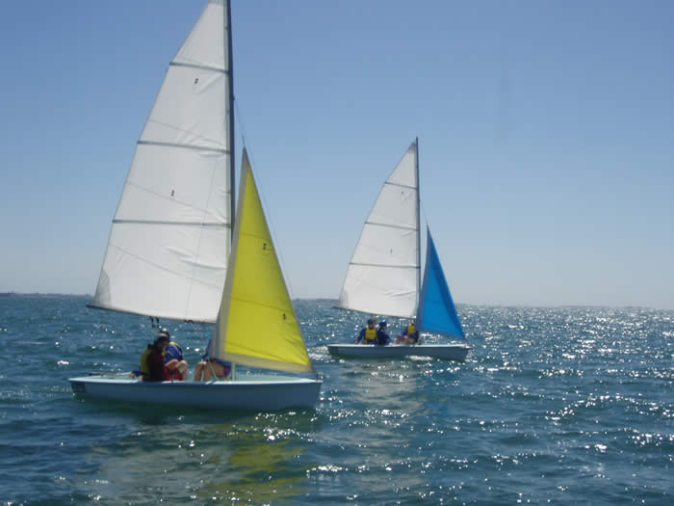
_Savage Dolphins  ................................................................  ‘Savage Dolphins’, which are used to support various programs, and are sailed by Victorian Sailing School staff with students at times when sailing dinghies is not suitable. | 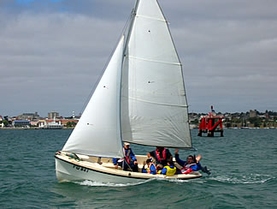

Critical dates:
- Applications open Monday 25th July 2020

- Applications close Friday 11th September 2020
- First round offer process will completed by Friday 9th October 2020

- Acceptance of offers close Friday 23rd October 2020

- Booking confirmation letters for 2021 sent to all Visiting Teachers and the Principal / Acting Principal / School Edumail Account of those schools / colleges by Friday 6th November

Website:
www.newcombsc.vic.edu.au/sailing_school/index

For further information Contact: Dave Matthews
Victorian Sailing School, 31 Eastern Beach Road Geelong
Mobile: 0409 508754
E-mail: matthews.david.I@edumail.vic.gov.au
For further information Contact: Dave Matthews
Victorian Sailing School, 31 Eastern Beach Road Geelong
Phone: 5221 8918
Mobile: 0409 508754
E-mail: matthews.david.I@edumail.vic.gov.au

‘The Sailing School is a Campus of Newcomb Secondary College’

